ppt-get update: apt command work on the database of available package. Apt-get update command will refresh the local database of available software. Once you run this command you can see information is getting fetched from various server.

root@ip-172-31-1-140:~# apt-get update Igr:2 http://us-east-2.ec2.archive.ubuntu.com/ubuntu focal-updates InRelease [114 kB] Hit:1 http://us-east-2.ec2.archive.ubuntu.com/ubuntu focal InRelease Get:2 http://us-east-2.ec2.archive.ubuntu.com/ubuntu focal-updates InRelease [114 kB] Reading package lists... Done

Hit: There is no change is package version. Igr: Package is being ignored Get: New version of package is available.

apt-get upgrade - Perform an upgrade

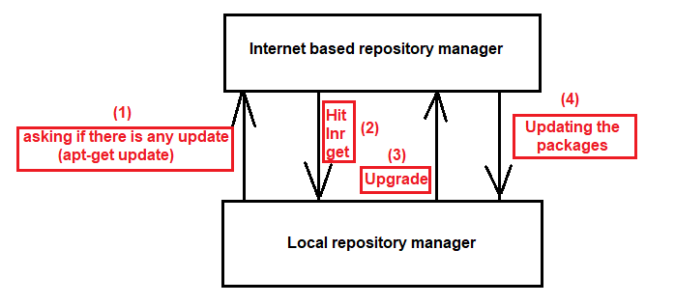

root@ip-172-31-1-140:~# apt-get upgrade Preparing to unpack .../23-open-vm-tools_2%3a11.1.5-1~ubuntu20.04.2_amd64.deb ... Unpacking open-vm-tools (2:11.1.5-1~ubuntu20.04.2) over (2:11.0.5-4) ... Setting up libglib2.0-0:amd64 (2.64.6-1~ubuntu20.04.3) ...

How package is getting ignored > We need to mark them as hold

apt-get update apt-get install -y kubelet kubeadm kubectl apt-mark hold kubelet kubeadm kubectl